Program : B. Tech (CSE)
Specialization :CSE
Course Title : DEVOPS2026
Course Code : 23CS102PE405
Semester : 6
Academic Session : 2025-2027
Name of Student : M. Sprusheeth Rao
Enrollment No. : 2303A51206
Batch No. : 04
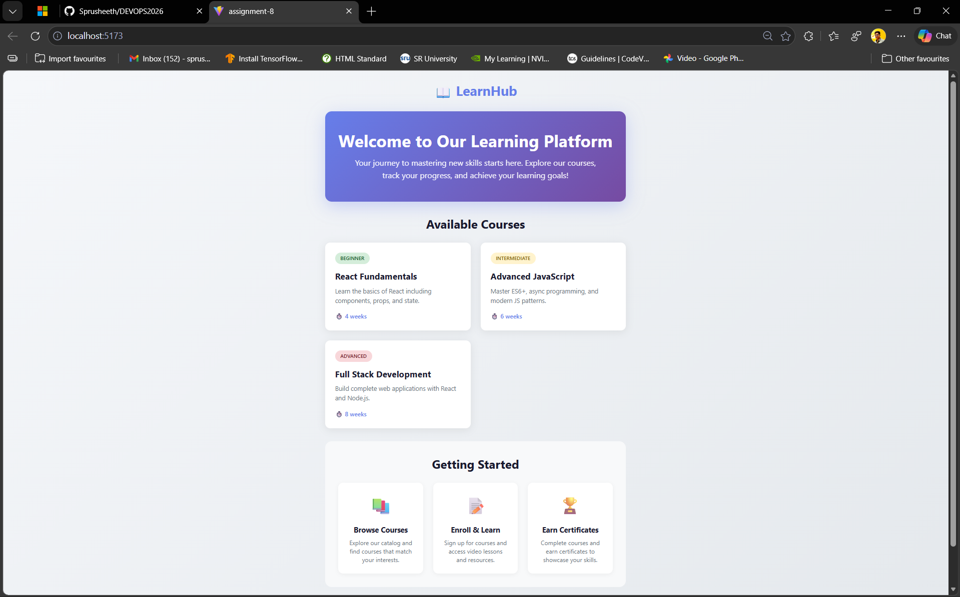
Date : 28 - 01-2026

1. Setting up a new React project using Create React App or Vite

Using Create React App (CRA)
Create React App provides a preconfigured environment suitable for beginners and small projects.
Steps: 1. Ensure Node.js and npm are installed. 2. Run the following command: bash npx create-react-app my-dashboard 3. Navigate into the project folder: bash cd my-dashboard 4. Start the development server: bash npm start The app runs on http://localhost:3000 with hot reloading enabled.

Using Vite
Vite is a modern build tool known for faster startup and optimized builds.
Steps: 1. Ensure Node.js is installed. 2. Run: bash npm create vite@latest my-dashboard 3. Select the React template. 4. Navigate to the project folder and install dependencies: bash cd my-dashboard npm install 5. Start the development server: bash npm run dev Vite serves the app with faster cold starts and efficient module loading.

2. Role of package.json in a React Project
The package.json file is the configuration and dependency management file for a React project.
It defines: - Project metadata (name, version, description) - Dependencies and devDependencies required by the application - Scripts for running common tasks such as development, build, test, and lint - Engine and tool configuration constraints
It allows consistent setup across different environments and simplifies dependency installation.

3. Creating a Functional Component in React
A functional component is a JavaScript function that returns JSX.
Example:
function Welcome() {
return <h1>Welcome to the Dashboard</h1>;
}
export default Welcome;
Functional components are simple, reusable, and support hooks for managing state and lifecycle behavior.

4. Rendering Components Inside the Main App Component
Components are rendered by importing them into the App component and using them as JSX elements.
Example:
import Welcome from './Welcome';
function App() {
return (
<div>
<Welcome />
</div>
);
}
export default App;
The App component acts as the root container for composing the UI.

5. Benefits of Breaking UI into Reusable Components
Breaking the UI into small reusable components provides several advantages:
- Reusability: Components can be reused across different parts of the application.
- Maintainability: Changes are isolated to specific components, reducing risk.
- Readability: Smaller components are easier to understand and debug.
- Scalability: Applications can grow without becoming tightly coupled or complex.
- Testability: Components can be tested independently.
This approach follows React’s component-based architecture and improves overall development efficiency.

